What if consciousness is fundamental and even primary?

I regard consciousness as fundamental, matter is derivative from consciousness. We cannot get behind consciousness. Everything that we talk about, everything that we regard as existing, postulates consciousness. There is no matter as such; it exists only by virtue of a force bringing the particle to vibration and holding it together in a minute solar system; we must assume behind this force the existence of a conscious and intelligent mind. The mind is the matrix of all matter.

– Max Planck

Well, the work my team and I have done has gone on to prove Max Planck is correct.

Erwin Schrödinger: There is only one mind
Austrian physicist Erwin Schrödinger is known for the phrase “The total number of minds in the universe is one. In fact, consciousness is a singularity phasing within all beings.” which best summarizes his philosophical outlook on the nature of reality. The phrase implies that the apparent multiplicity of minds is just an illusion and that there is only one mind, or one consciousness, that expresses itself in a myriad of ways.
Schrödinger also stated that “consciousness cannot be accounted for in physical terms. For consciousness is absolutely fundamental. It cannot be accounted for in terms of anything else”. This reflects the idea of panpsychism, the view that all existence is permeated by consciousness and that consciousness is the underlying reality – rather than just something that is produced by brains of a certain complexity.
Erwin is almost right . . . though he is missing some vital data.

Albert Einstein remarked that we humans only use about 10% of our abilities . . . our findings are different: we may not be using even 1%

In the present, humanity and the practice of medicine and psychological treatments have actually practiced what has been observed to be a misplaced priority:

From Chapter 1 of my book . . . How to Learn—How to Teach: Overcoming the Seven Barriers to Comprehension:
Another related and very interesting change that was recently introduced, which altered the conventional wisdom of psychology and the social sciences, was revealed in an interview with Professor Martin E.P. Seligman, the (then) president of the American Psychological Association, in the April 28, 1998, edition of The New York Times, Science News section. The article begins:
Psychologists rarely think much about what makes people happy. They focus on what makes them sad, on what makes them anxious. That is why psychology journals have published 45,000 articles in the last 30 years on depression, but only 400 on joy. . . . .
It was not always like that. When psychology began developing as a profession, it had three goals: to identify genius, to heal the sick and to help people live better, happier lives. Over the last half century, however, it has focused almost entirely on pathology, taking the science of medicine, itself structured around disease, as its model. . . .
’That is an imbalance,’ says Martin E.P. Seligman, the new president of the American Psychological Association, and one that he is determined to change. Dr. Seligman, a professor at the University of Pennsylvania . . . has a strategy for reforming a profession he thinks has gone awry. . . .
’Psychology,’ he said, ‘has been negative essentially for 100 years. Theories have generally focused on damage, as have techniques for intervention. Social science has believed negative things were authentic and strengths were coping mechanisms,’ he said. . . .
But what he sees in his (own) children are ‘pure, unadulterated strengths that are not compensations for trauma, but intrinsic.’ Seligman says, ‘I find myself beginning to believe psychology needs to ask, what are the virtues? We need to delineate them, assess them, ask causal questions. What are the interactions? How does it grow? Let’s talk of growth and questions of strength. . . .’
’Rather than spending $10 million on, say, phobias and fears,’ he says, ‘study courage.’
The point raised by Dr. Seligman is a very important one, and one we are particularly delighted to see raised within mainstream psychology circles. It is an issue that was addressed by Alan Walter and me more than forty years ago in our work with champion athletes and in improving human performance generally. That work continued, and the discoveries made over the last few years demonstrate the issue raised by Dr. Seligman is now very much resolved.
The discoveries and technology developed by Alan Walter and me are of particular and immense value here, as they explain, and provide procedures for the recovery and empowering of the true powers of you as a spiritual Being.
The real you, when it is recognized, honored and appreciated fully in oneself and in one’s children or students, produces wondrous results.

****

Of course, once one validates the truth of our Spiritual Existence, one can then begin to accept and validate the truth of our prior existences and reincarnation.

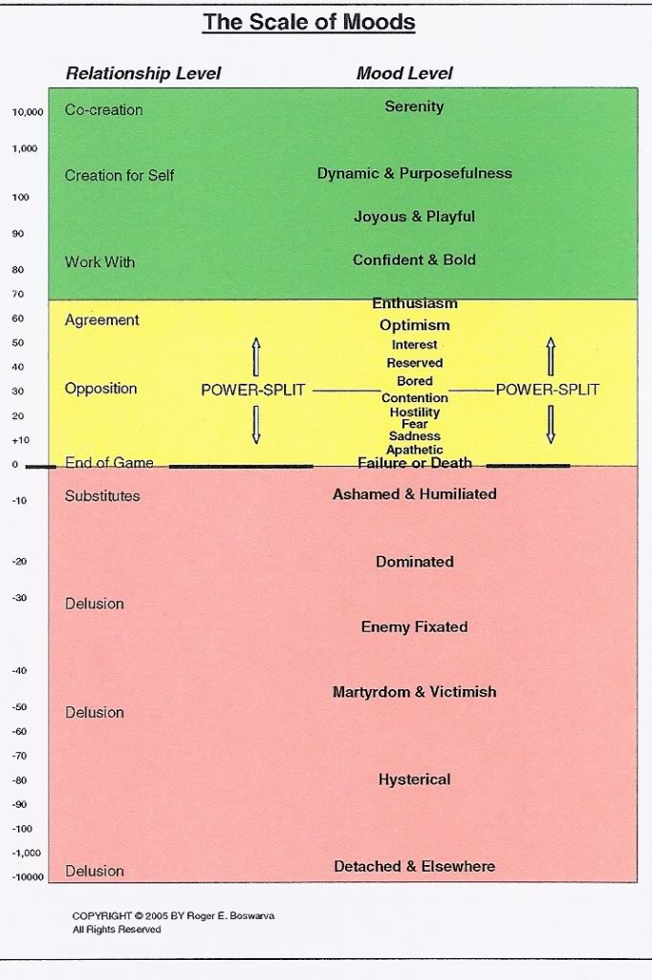

These are loosely referred to as “universes,” but they are more correctly, states or domains of Spiritual existence, presence and Beingness.

1. THE “HEAVENS” UNIVERSE - Ultimate Beauty, Unity, Alignment and Harmony of THE SUPREME BEINGS (The Singularity arising as a result of our perfect union)

2. THE UNIVERSAL VISIONS . . the envisioning of the ending of not wanteds and the envisioning of what will be (instead). This began our decline from perfect unity, and created the concept of future TIME.

3. THE UNIVERSAL MIND . . . the solution of “putting unwanteds behind” oneself “there, to control it out of here and now”

4. THE SPIRITUAL GODS GAMES UNIVERSE . . . the creating/envisioning of spatial dimension with self separate at “here” separate from others at “there”

5. THE HOME UNIVERSE

6. THE EVIL BEING UNIVERSE

7. THE SUBDUING OF EVIL BEINGS UNIVERSE

8. THE OPPOSING SPIRITUAL OBJECTS UNIVERSE

9. THE SPIRITUAL BEING IDENTITIES UNIVERSE

10. THE COMPETITORS UNIVERSE

11. THE RATIONALIZATION UNIVERSE

12. SPIRITUAL BEINGS AS OBJECTS UNIVERSE

13. THE YOUR OWN AND OTHER'S VALUABLE CREATIONS UNIVERSE

14. THE KILLING OF SPIRITUAL DREAMS AND OBJECTS UNIVERSE

15. THE DEAD SPIRIT UNIVERSE (Having had all its Dreams, Aspirations, Creations and Purpose destroyed the Being felt lifeless and unable to engage in Life.)

16. THE PHYSICAL UNIVERSE (The solution to being spiritually dead.)

*

Our decline down through the above sequential list of States of Being and Spiritual Existences was the result of our wrong answer solutions to what was not wanted to be experienced in each of the preceding levels or states of spiritual Being.

The above shows the sequence of our spiritual decline that occasioned the creation of time, then space, and followed by the creation of physical matter. Note the later universes fit within the earliest universe

OUR ORIGINAL MOST PURE STATE

The Heavens Universe was the basic universe on the chain of events that led us to the state we are now in on earth.

There are 25 basic universes.

I. THE HEAVENS UNIVERSE - THE LOVING INFINITE UNITY OF SUPREME SPIRITS CO-EXISTING AS THE SUPREME BEING: This was a voluntary universe.

This universe was the epitome of the composite, co-existence of all optimum spirituality. All spiritual beings were in unity, though each was able to maintain its own selfness. It existed and operated as an infinite loving oneness that was composed of all life forces interacting as an infinity of pure and total love.

To achieve and maintain this level of existence required that each being had the attributes of an infinity of:

Love
Knowledge
Immortality
Honesty
Integrity
Truth
Skills
Wisdom
Presence
Sovereignty
Ownership
Power
Cause
Effect
Mercy
Duplication
Permeation
Capability
Ability
Honor
Appreciation
Responsibility
Affection
Comprehension
Communication
Harmony
Accord
Care
Respect
Acknowledgement
Adoration
Friendliness
Warmth
Elation
Joy
Gaiety
Happiness
Connectedness
Forgiveness
Tolerance
Charity
Empathy
Energy

Each being had its full god-like abilities and used them to perfection.

This basic universe existed before the need for time, space and particles. It had no physical properties. No other universes existed.

On November 28, 2006, I added the attribute of INFINITE POTENTIAL.

We have a procedure titled: GOD-LIKE ATTRIBUTES REHABILITATION PROCEDURE (UB8)

This is an exchange of emails Alan and I had in November, 2006.
We often exchanged research "notes."
The word "Spirita" is defined as a quantity of spiritual presence that is not involved in any relationship or activity, and is thus utterly free and pure.
Tuesday, November 28, 2006 2:25 PM
To: rb .com.
Subject: NEW AXIOM 1
Dear Rog,
Thanks for the research material.
This may be of some help.
A.
NEW AXIOM 1
NEW AXIOM 1. LIFE IS BASICALLY AN EMANATION STEMMING FROM A LIFEFORCE PRESENCE
Definition: A Lifeforce Presence is pure Spirita it has no mass, no motion, no wavelength, no form, no limitation, no location in space or in time.
A Lifeforce Presence is infinite in depth, breadth, size and scope.
A Lifeforce Presence in its purest state is capable of infinite aliveness, infinite powers, infinite duplication, infinite permeation, infinite intelligence, infinite abilities, infinite cleverness, infinite strengths, infinite skills, infinite creation, infinite love, infinite truth, infinite harmony, infinite knowledge, infinite know-how, infinite responsibility, infinite control, infinite experience, infinite exchange and infinite integrity it should be noted that each one of these infinite capabilities also has no mass, no motion, no wavelength, no form, no limitation, no location in space or in time.
A Lifeforce Presence is in a state of oneness with all these capabilities.
A Lifeforce Presence is senior to all gradient scales and the mechanics of life.
A Lifeforce Presence has the ability to create and to perceive.
A Lifeforce Presence is the infinity of Spirita (8) that creates the containers of the becomingness of the Infinity to Zero of Spirit (8 to 0+) - to the Zero to Infinity of Space, Time, Energy and Matter. (-0 to 8) = 8 – 8008.
ALAN
OLD AXIOM 1. LIFE IS BASICALLY A STATIC.
Definition: A Life Static has no mass, no motion, no wavelength, no location in space or in time. It has the ability to postulate and to perceive.
________________________________
I replied next day:
New Axiom 1---Something Omitted
Dear Alan,
I’ve been chewing on the New Axiom 1, and I do believe we have a very important item omitted. It is:
A Lifeforce Presence has infinite potential.
One could use the less familiar noun form, “potentiality.” Good big dictionaries give wonderful expressions of what these concepts are in the context of an attribute of the state of existence of pure Spirita.
This is a big concept. The stem word, of course is potent. And the original definition of it as an adjective is: that has power; potent. A modern adjective definition is: that can, but has not yet, come into being; possible; latent; unrealized; undeveloped; opposed to actual. The noun definition is: something potential; a potentiality. (These definitions from Webster’s New Twentieth Century Dictionary, Unabridged Second Edition (Simon & Schuster.) A simple noun definition of it from The American Heritage Dictionary, Second College Edition, is: The inherent ability or capacity for growth, development, or coming into being.
I have for the last several months been processing in the area of this state of “ultimate, infinite potential/potentiality” and the what stemmed from it when, as a “Life-Force Presence of infinite potential,” (and interestingly I did use those words to articulate the scenario in session) I and/or we acted to convert the potential to express actual states of Being or conditions of existence, and produced “things”.
Hence my view that we need to add this concept to complete the full statement of New Axiom 1.
Rog
___________________________
Alan did embrace my bright little contribution. In his lecture dated October 16, 2007, titled "Life" his opening dissertation about "Life" was all to do with this concept of its innate potential.

DEFINITIONS

Charge: Misaligned negative Spiritual Life-Force that has become unknown to you and outside of your knowing control

The MIND: the recordings and accumulation of impacts and impressions in and upon your spiritual Life-Force that you have experienced or suffered during your existence along with the recording of your own wants, intentions and creations. The mind exists today in the form of those recordings that impressed on and altered your Life-Force Presence.

The physical universe construct of Time, Space, Energy and Matter is the result of collisions and opponency of Spiritual Life-Force projections resulting in the stasis of standing waves or patterns of arrested motion.

ENERGY: Science has failed to define and make known what is the “stuff” of energy; of what is it composed ---- ENERGY is not “ability to do work, which is the ability to exert a force causing displacement of an object.”
Our finding is that the basis and “stuff” of all energy in the physical universe is the Primal Spiritual Life-Force as and when directed and deployed by the Infinite Spiritual Presence engaging in the manifestation of “LIFE.” (In other words, you natively manifest “energy” when you direct your Life-Force.)

https://www.youtube.com/watch?v=Vkwa_s2zmAQ
Deepak Chopra embarrasses himself and guests on “Consciousness”

apperceive
verb (used with object), ap·per·ceived, ap·per·ceiv·ing.Psychology.
to have conscious perception of; comprehend.
to comprehend (a new idea) by assimilation with the sum of one's previous knowledge and experience.

rboswarva@abilityconsultants.com

